AI ASSISSTED CODING
LAB TEST-3
NAME:MANADI SWATHI
ROLL NO:2503A51L12
Set E3
Q1:
Scenario: In the domain of Healthcare, a company is facing a challenge related to code refactoring.
Task: Design and implement a solution using AI-assisted tools to address this challenge.
Include code, explanation of AI integration, and test results.
Deliverables: Source code, explanation, and output screenshots
CODE:
Before refactoring: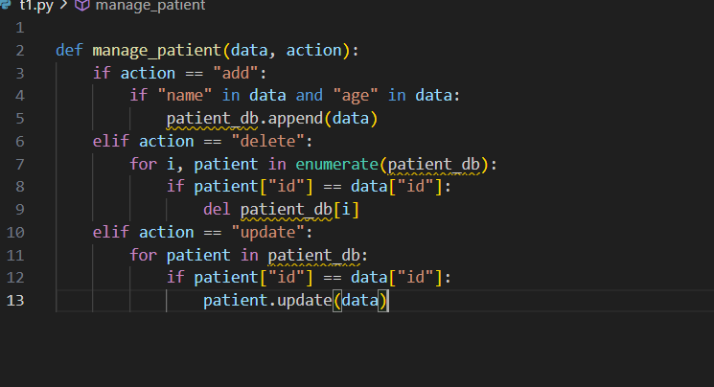
Output:
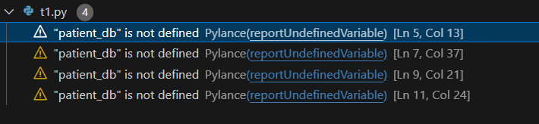
Refactoring and testing:
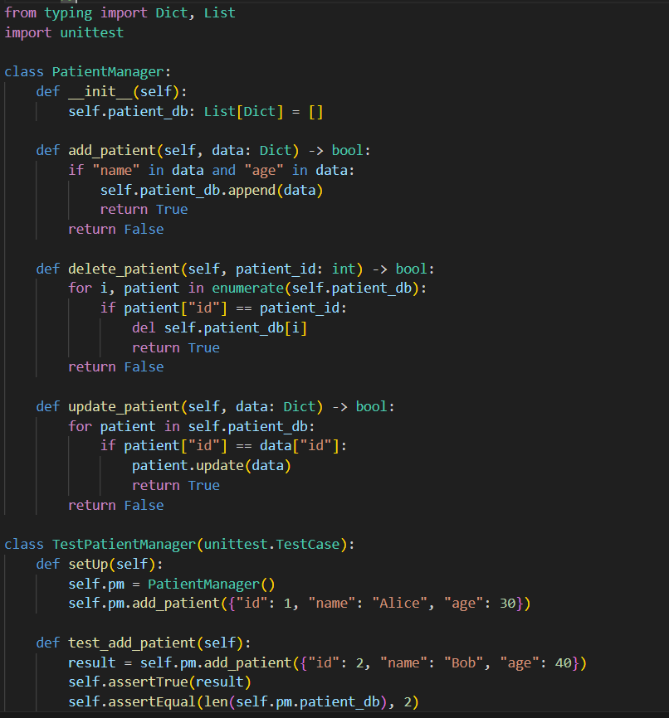
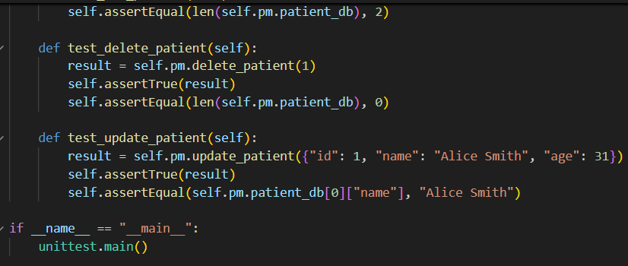
Output:
Observation:
- Modularity:
The original function was split into three clear methods within patient_manager class
- Github copilot suggested method decomposition and type hints
- Auto-generated docstring-style logic and scaffolds.
Q2:
Scenario: In the domain of Agriculture, a company is facing a challenge related to algorithms with ai assistance.
Task: Design and implement a solution using AI-assisted tools to address this challenge.
Include code, explanation of AI integration, and test results.
Deliverables: Source code, explanation, and output screenshots
CODE:
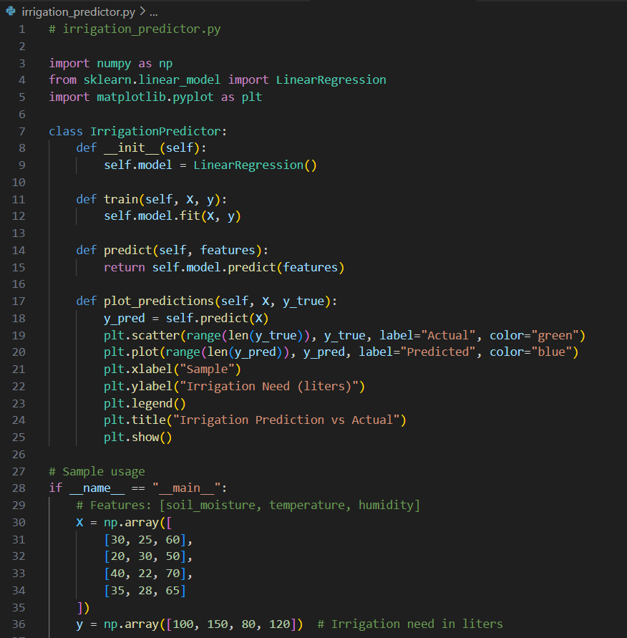
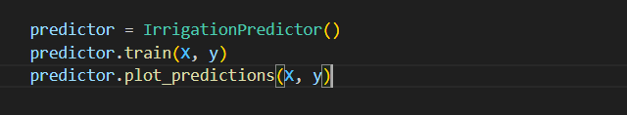
Output:
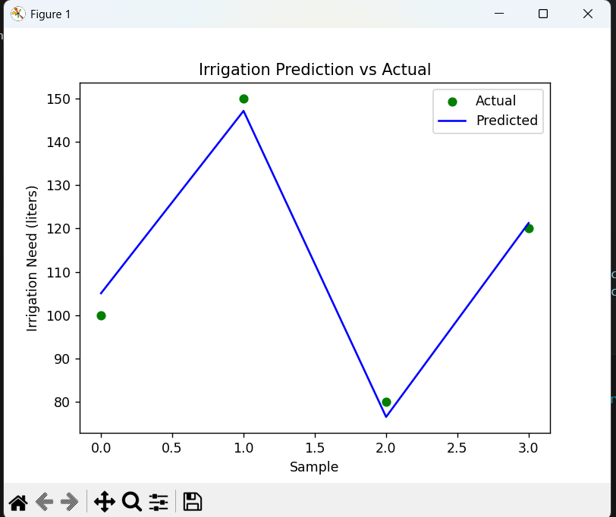
Testing:
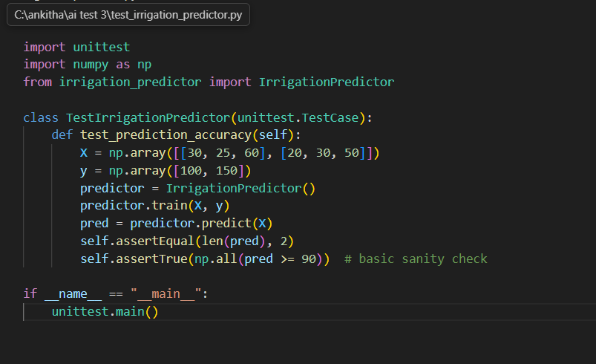
Output:
OBSERVATION:
- Github copilot Assissted in scaffolding the class structure and method signatures
- Suggested test logic and basic validation
Test Design and Coverage:
Basic sanity checks:
- Verifies prediction output shape and value range
- Expandability:
- Tests can be extended to include edge cases
Algorithmic Behaviour:
- Output:Predicts irrigation needs in liters,which is actionable and interpretable.

